Team,

Data brings us together. I started by telling a story. As a gift to the team, let me go ahead and finish that story first.

Aoccdrnig to a rscheearch at Cmabrigde Uinervtisy, it deosn't mttaer in waht oredr the ltteers in a wrod are, the olny iprmoatnt tihng is taht the frist and lsat ltteer be in the rghit pclae. The rset can be a toatl mses and you can sitll raed it wouthit porbelms. Tihs is bcuseae the huamn mnid deos not raed ervey lteter by istlef, but the wrod as a wlohe.

I believe that you can read and understand the above content. That’s great, you’re human! If not, you can stop here.

Just kidding.

When I was in college, my major was Teaching Chinese as a Foreign Language. So I was supposed to read a lot of literature books. But I didn’t really enjoy reading that much since I read too slowly. At the same time, one of my roommates could read 5 books a day, and we’re talking one-inch-thick books. I was shocked. How could other people read so fast? I eventually found out their secret – you can train yourself to read faster.

Here are the three stages of reading from beginner to advanced.  The arrows are the route your eyes follow as you read.

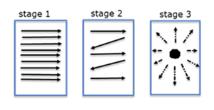

I am a beginner reader, I read word by word, line by line. After training, people can get to the stage 2 by reading forward and backward and also skipping lines. You know the order of the words doesn’t really affect your reading. The super advanced reader can put their eyes in the center of a page and read everything all at once.

YES, this is the secret! However, not everyone can get to the stage 3, even with a lot of practice. BUT big data technology can do this for you. Our project will allow you to witness how computers read and manipulate tons of data in a short amount of time, and extract out key information.

My goal is to develop a system using Spark on the Hadoop platform to shorten the time for manipulating data while reducing costs.

1. Team members name and contact

Kleffman, Jake <kleffj1@nationwide.com>;

McGee, Kevin V <kevin.mcgee@nationwide.com>;

Berke, Lisa M <lberke@nationwide.com>;

Chakravarty, Lopamudra <chakrl2@nationwide.com>;

Yang, Liusong <liusong.yang@nationwide.com>;

Cao, Lily <CAOL1@nationwide.com>;

1. Architecture of the project

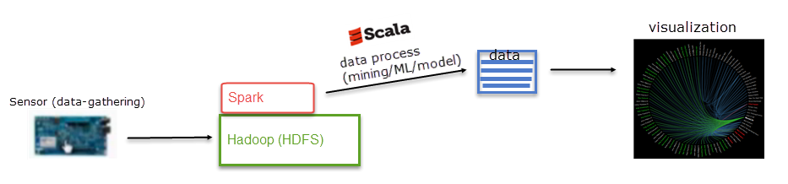

In this project, Liusong and I are the developers and will handle the technical aspects of this project. We can share our ideas from our own fields, like business intelligence, insurance business, data resources, statistics, visualization tools, presentation…

Let me know if you want to set up a meeting and when.

Thanks!

Lily Cao